Mini-SOC in a Box
Week 1 | Build the Lab and Deploy Wazuh
Prepared by Nazrin Aliyeva

Technical Implementation and Verification Report
Wazuh 4.14.8 • Ubuntu Server 24.04 • Windows 10 • VMware Workstation Pro

Contents
1. Executive summary and project objectives
2. Laboratory architecture and inventory
3. Networking, isolation and time synchronization
4. Docker and Wazuh deployment
5. Security configuration
6. Endpoint telemetry and Apache
7. Five event verification scenarios
8. Event-to-alert flow (V2)
9. Reliability, resource use and snapshots
10. Troubleshooting and lessons learned
11. Operating procedure
12. Conclusion and references

Requirement coverage
Group | Evidence in this report
L1–L5 | VM inventory, addressing, connectivity, time, Docker prerequisites, snapshots
W1–W5 | Container deployment, HTTPS, password change, persistence, memory
A1–A4 | Two Active agents, Sysmon telemetry, Apache access
V1–V2 | Five alert records and end-to-end event path
S1–S2 | Credential-handling note and isolation proof
D1–D3 | Consolidated architecture, procedure, troubleshooting and work log

1. Executive summary and project objectives
The Week 1 objective was to establish a small, isolated security operations laboratory for the fictional LabShop environment: one Wazuh monitoring server, one Linux web server and one Windows workstation. The completed lab enables endpoint registration, collection of Linux authentication activity and Windows Sysmon telemetry, centralized alerting and basic investigation through the Wazuh Dashboard.
The deployment uses VMware Workstation Pro and a single-node Wazuh 4.14.8 Docker stack. Both endpoints have fixed IP addresses on a private host-only network; internet routing is not configured on either endpoint. Five controlled activities were deliberately generated, and each appeared in the Dashboard as an alert.

Learning outcomes
- Construct an isolated virtual network with predictable addressing and reliable clocks.
- Deploy and operate Wazuh Manager, Indexer and Dashboard using Docker Compose.
- Enroll Linux and Windows agents and augment Windows Event Logs with Sysmon.
- Trace a concrete endpoint action from a source event to a searchable SOC alert.
- Verify basic persistence, resource consumption and the ability to recover from configuration changes.

2. Laboratory architecture and inventory
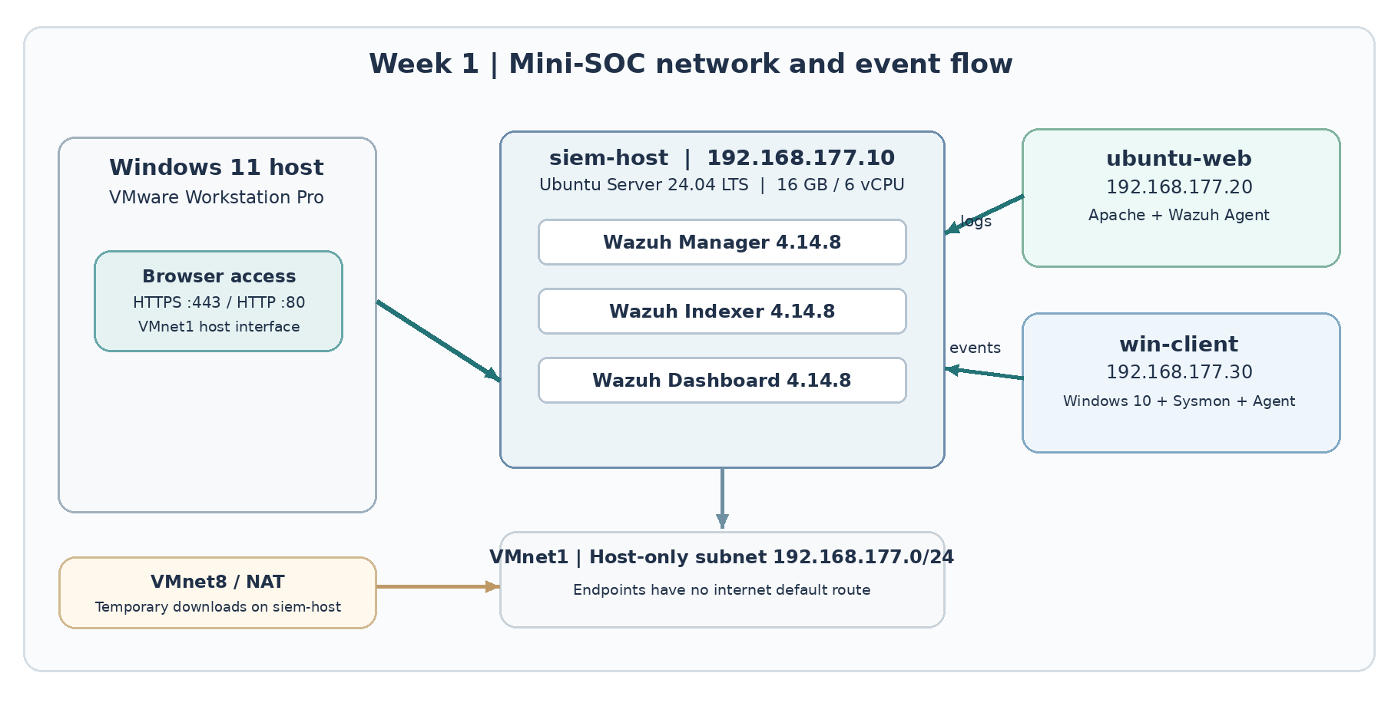
Figure 1. Actual architecture, IP addresses, traffic direction and network isolation.
All three VMs run on a Windows 11 host with 32 GB of RAM. VMnet1 retains the VMware host-only network 192.168.177.0/24. The SIEM host also uses a NAT adapter for approved package downloads and updates; the Linux and Windows endpoints operate without a default internet route.
Machine | OS / role | Memory | vCPU | Disk | Host-only IP
siem-host | Ubuntu Server 24.04 LTS; Wazuh Docker | 16 GB | 6 | 250 GB | 192.168.177.10
ubuntu-web | Ubuntu Server 24.04 LTS; Apache + agent | 2 GB | 2 | 40 GB | 192.168.177.20
win-client | Windows 10 Enterprise Eval 22H2; Sysmon + agent | 4 GB | 2 | 80 GB | 192.168.177.30

3. Networking, isolation and time synchronization

3.1 Connectivity and controlled routing
All six directed VM-to-VM ping tests succeeded with zero packet loss. The physical host can access Wazuh at https://192.168.177.10 and Apache at http://192.168.177.20 through VMnet1.
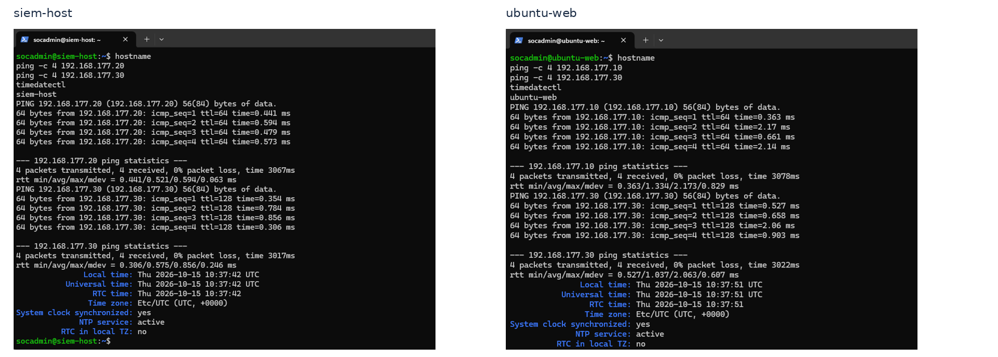
Figure 2. Linux VM connectivity tests and synchronized clocks.
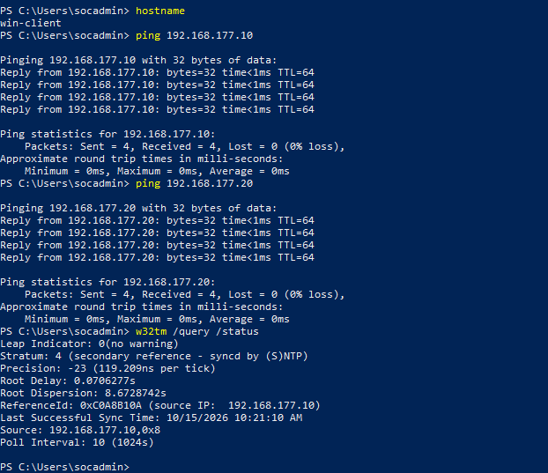
Figure 3. Windows client connectivity to both Linux VMs and NTP status.

3.2 Network isolation
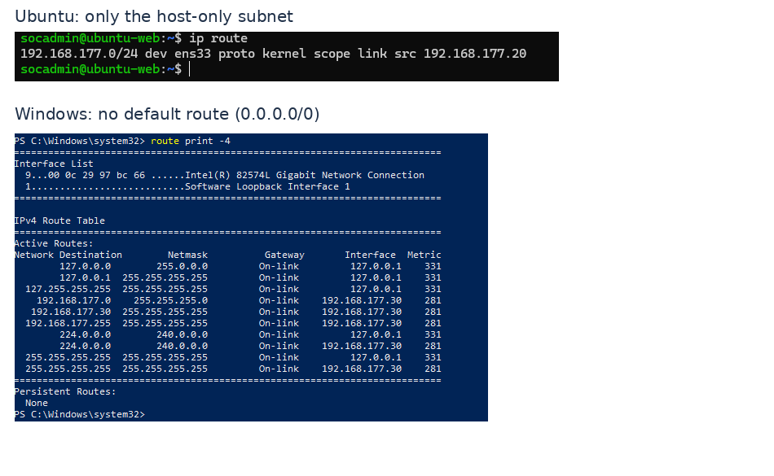
Figure 4. Neither endpoint has a default route to the internet.
Only the connected 192.168.177.0/24 host-only subnet and standard loopback/link-local entries were present on the endpoints. The SIEM host retained NAT capability to acquire Docker images and updates; endpoints had only temporary NAT access during initial provisioning.

3.3 Shared clocks
Chrony was configured on siem-host to serve the lab subnet. ubuntu-web and win-client used 192.168.177.10 as their time reference. The verified Windows Time-Service status had Leap Indicator 0, stratum 4 and source 192.168.177.10. A four-hour difference between VM terminal timestamps and browser display reflected UTC versus UTC+4, not clock drift.

4. Docker and Wazuh deployment

4.1 Host prerequisites and single-node stack
Docker Engine and the Compose plugin were installed on siem-host from Docker’s official repository. The host kernel vm.max_map_count was verified as 1048576, meeting the Indexer requirement. A Docker hello-world test succeeded before deployment. Wazuh version 4.14.8 was deployed from the Wazuh single-node Compose configuration.
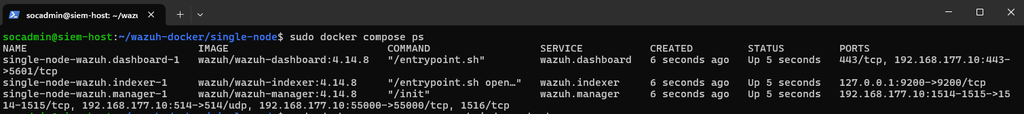
Figure 5. Wazuh Manager, Indexer and Dashboard containers running on version 4.14.8.
Component | Function
Wazuh Agent | Collects endpoint events and transmits them to the Manager.
Wazuh Manager | Receives, decodes and applies rules to events to generate alerts.
Wazuh Indexer | Stores and indexes alert documents for retrieval.
Wazuh Dashboard | Presents endpoint status, alerts and interactive investigation views.

4.2 Service exposure and HTTPS access
Published Docker ports were restricted to the SIEM host-only address. Agent traffic used 1514/TCP and enrollment used 1515/TCP; syslog 514/UDP and Wazuh API 55000/TCP were also bound to 192.168.177.10. The Dashboard used 192.168.177.10:443, while Indexer port 9200 was bound to loopback (127.0.0.1).
The Dashboard was accessed at https://192.168.177.10. Its initial certificate warning was expected because the lab used a locally generated certificate authority that is not trusted by the physical host’s browser. The warning was acknowledged only after verifying the private lab destination.
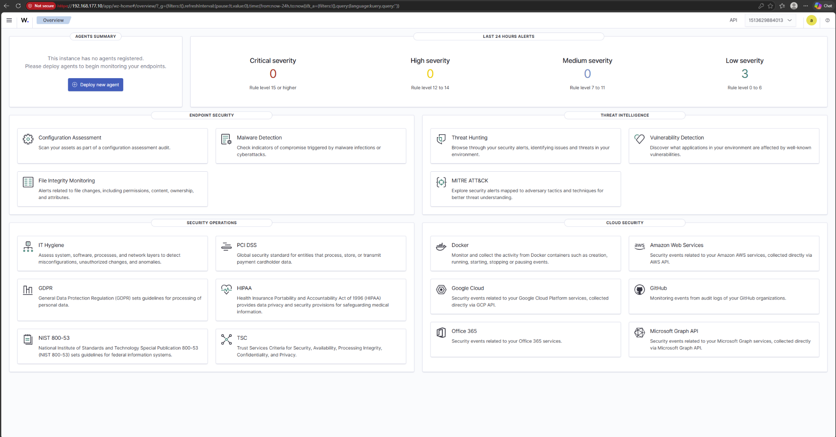
Figure 6. Initial Wazuh Dashboard accessible over HTTPS from the physical Windows 11 host, before agent enrollment.

5. Wazuh security configuration

5.1 Administrative credential hardening
The default Wazuh administrator password was replaced using the documented Docker workflow. The administrator hash was generated locally, the Indexer’s internal user configuration and dependent Compose password references were updated, and the Indexer security configuration was reapplied with securityadmin.sh. Login using the new password succeeded.
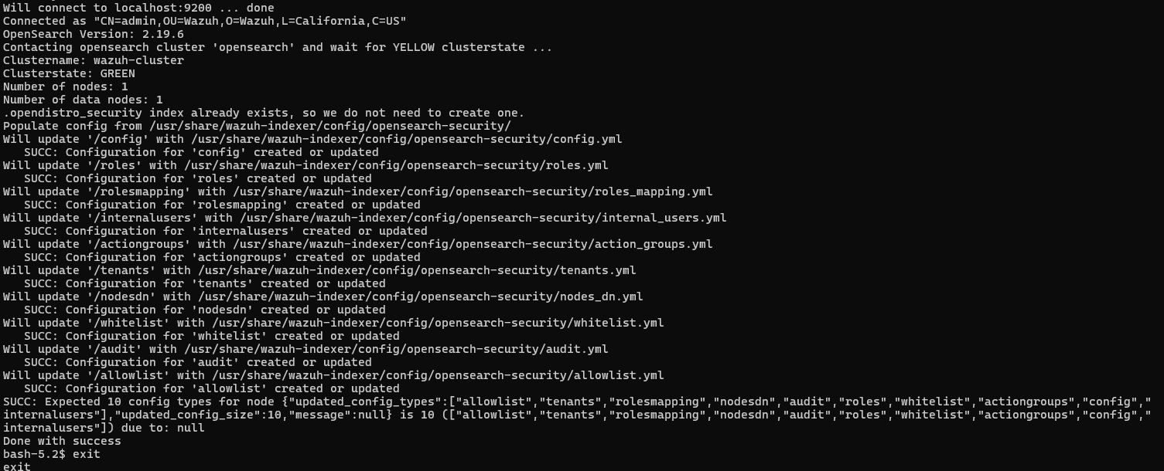
Figure 7. Successful Indexer security configuration update (including internal users).

5.2 Restricted service exposure
Binding the public Dashboard and Manager ports only to 192.168.177.10 reduced unintended exposure on the temporary NAT interface. Binding Indexer port 9200 to loopback reduced direct network access to the Indexer API. These bindings supplement VMware network isolation rather than replace firewall controls.

6. Endpoint telemetry and Apache

6.1 Ubuntu and Windows agents
Wazuh Agent 4.14.8 was installed on ubuntu-web using an offline-transferred Debian package and on win-client from an MSI copied to the VM. The Manager address was configured as 192.168.177.10. The Linux agent service was enabled at boot and the Windows agent service runs automatically. Both agents eventually showed Active in the Dashboard.
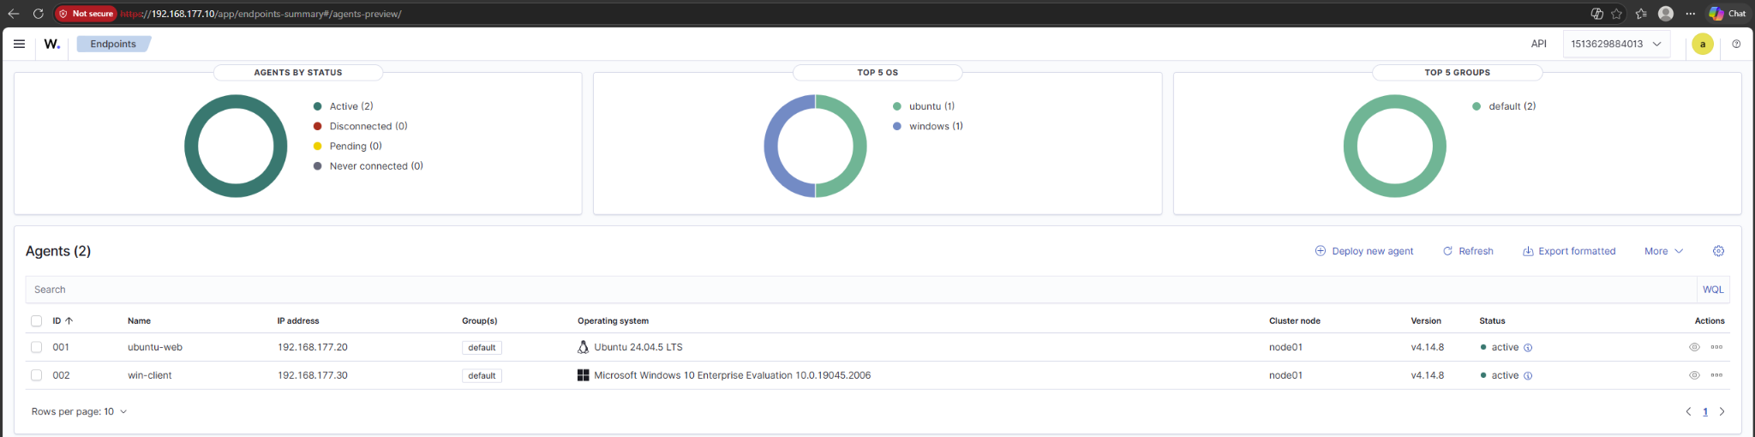
Figure 8. Two registered and Active endpoints: ubuntu-web (001) and win-client (002).

6.2 Sysmon telemetry
Microsoft Sysmon v15.22 was installed on Windows 10 with the SwiftOnSecurity community XML configuration. The Wazuh Windows agent was configured to read the Microsoft-Windows-Sysmon/Operational event channel. Local Event ID 1 process creation was confirmed with PowerShell, and corresponding Notepad process metadata appeared in Wazuh Discover.
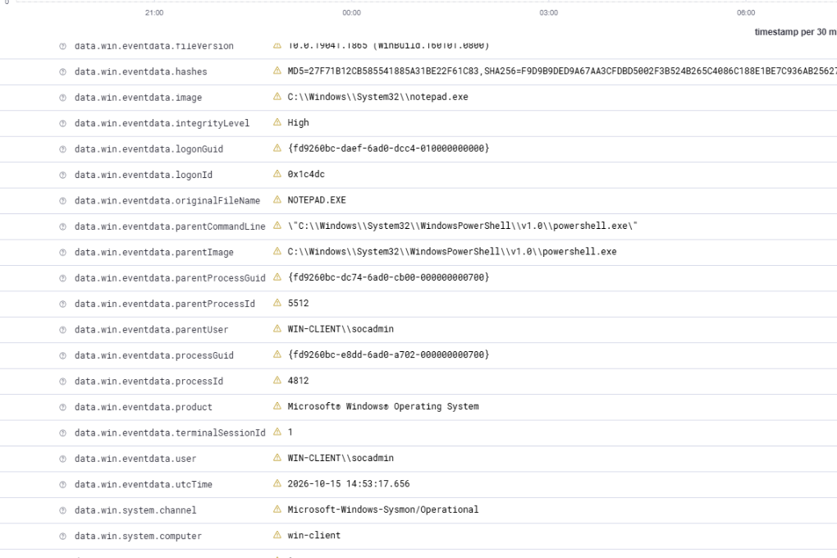
Figure 9. Event ID 1 for notepad.exe in Wazuh, including parent process and image path.
Sysmon’s standard Event ID 1 rule (61603) is level 0 and does not itself generate an indexed alert. For this controlled lab validation, a scoped level-5 custom rule (100150) was added for notepad.exe so that a benign, reproducible process start could be shown in the alerts index. This is a test rule, not a malware verdict.

6.3 Apache web server
Apache2 was installed on ubuntu-web and its default site was opened successfully from the physical Windows 11 browser at http://192.168.177.20. The browser displayed a “Not secure” indicator because the default site used HTTP.
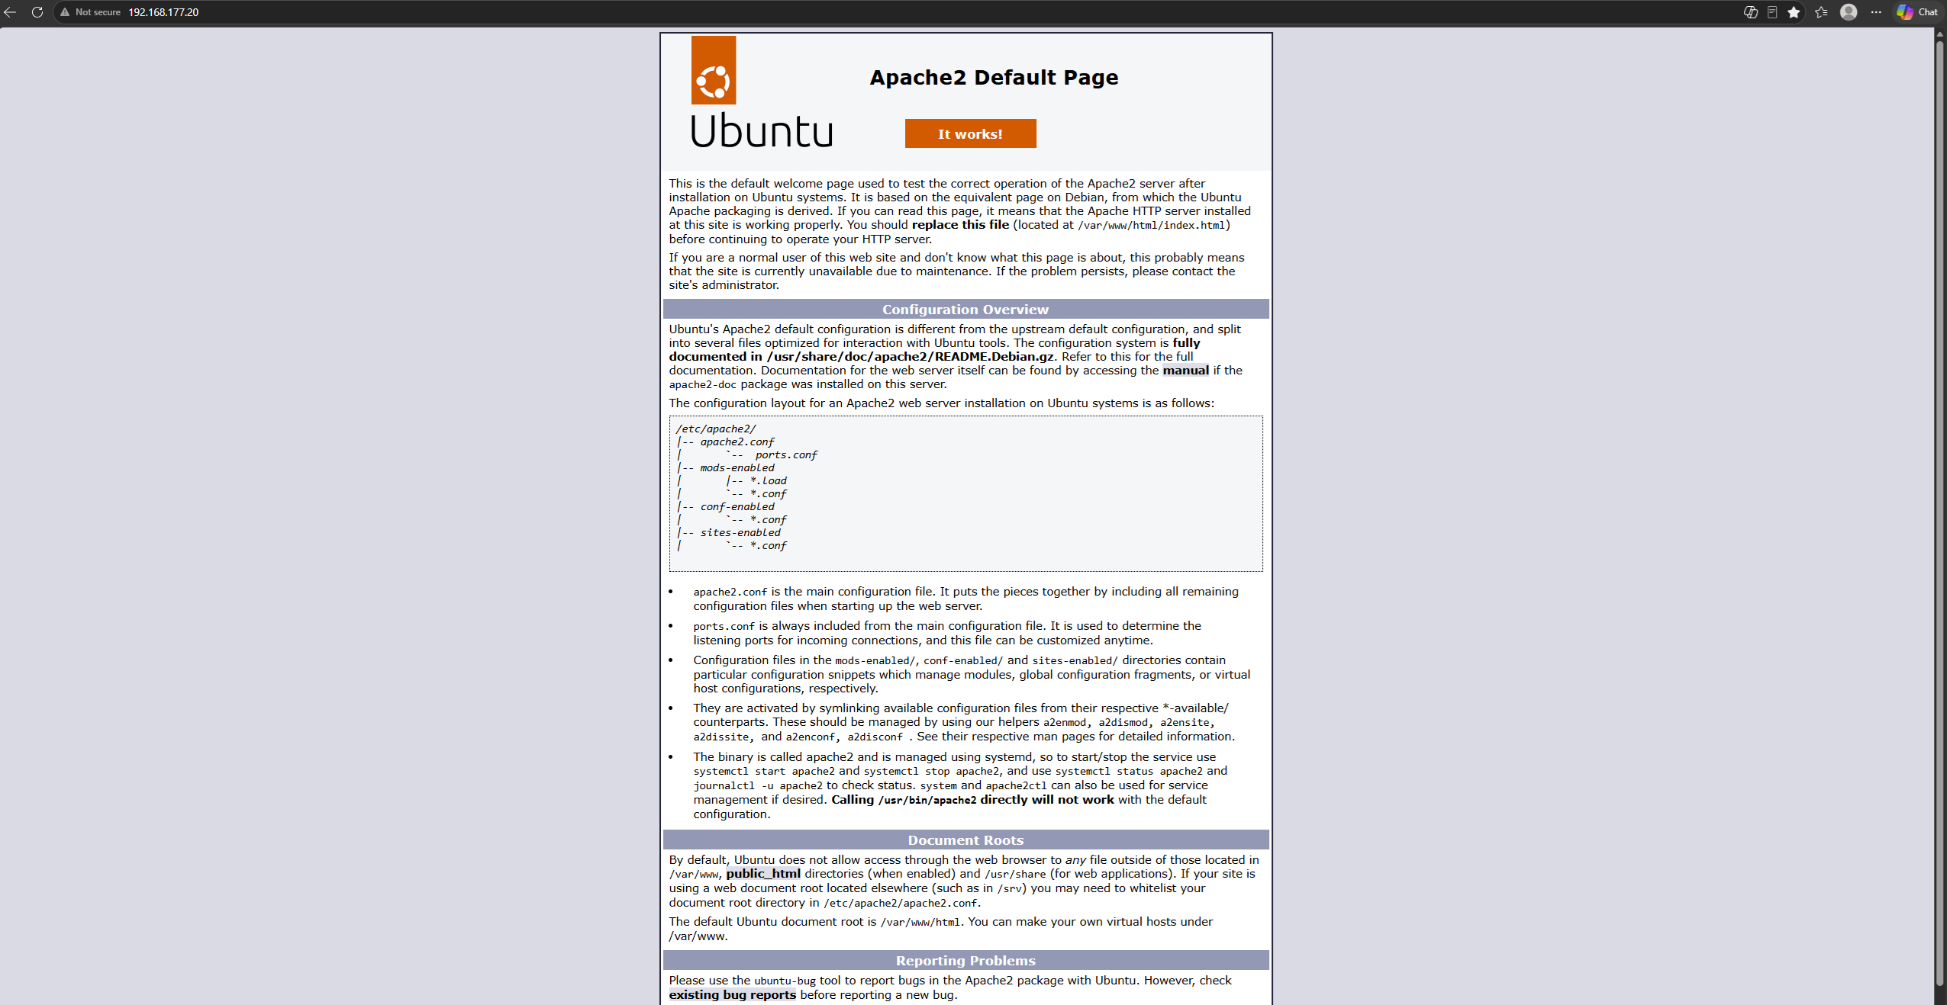
Figure 10. Host-browser access to Apache2 on ubuntu-web..

7. Five event verification scenarios (V1)
Each required activity was deliberately generated within the isolated lab, observed on its endpoint where applicable, and located in the Wazuh alerts index. The table below records actual observed rules rather than estimated severities.
Test / endpoint | Observed rule | Level | Evidence
1. Failed SSH login / ubuntu-web | 5503 — PAM: User login failed. | 5 | Figure 11
2. sudo whoami / ubuntu-web | 5402 — Successful sudo to ROOT executed. | 3 | Figure 12
3. useradd soclabtest / ubuntu-web | 5902 — New user added to the system. | 8 | Figure 13
4. Start Notepad / win-client | 100150 — LAB TEST - Sysmon Notepad process creation | 5 | Figure 14
5. Failed Windows logon / win-client | 60122 — Logon Failure - Unknown user or bad password | 5 | Figure 15

7.1 Failed Linux SSH authentication
One deliberately incorrect SSH password attempt for socadmin was made from the physical host. Ubuntu recorded the failure, and Wazuh created the PAM authentication-failure alert (rule 5503, level 5). The event identified source 192.168.177.1 and showed a login failure on ubuntu-web.
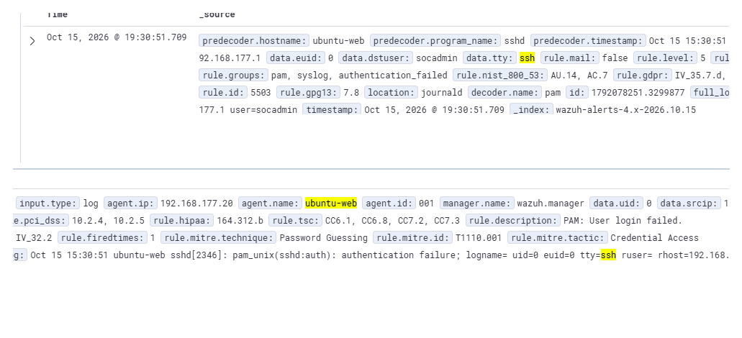
Figure 11. Wazuh alert for the failed SSH password attempt.

7.2 Successful privileged command
The command sudo whoami returned root. The sudo record was forwarded from ubuntu-web and Wazuh reported “Successful sudo to ROOT executed” (rule 5402, level 3).
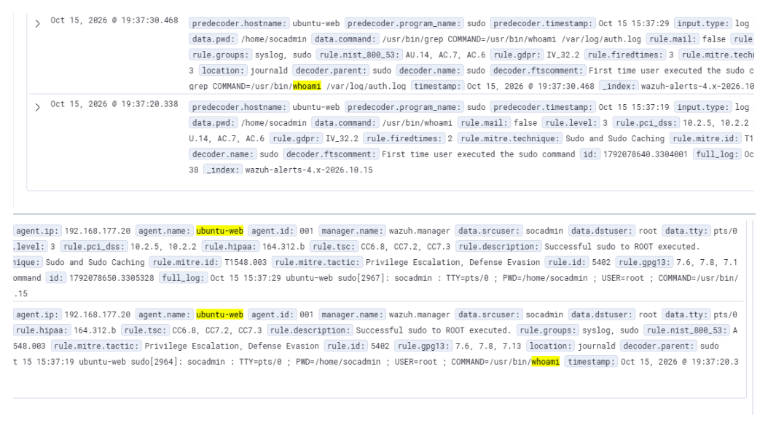
Figure 12. Wazuh alert for sudo whoami on ubuntu-web.

7.3 Local Linux user creation
A temporary account named soclabtest was created with useradd -m -s /bin/bash. Wazuh produced “New user added to the system” (rule 5902, level 8), and also recognized the associated new group (rule 5901).
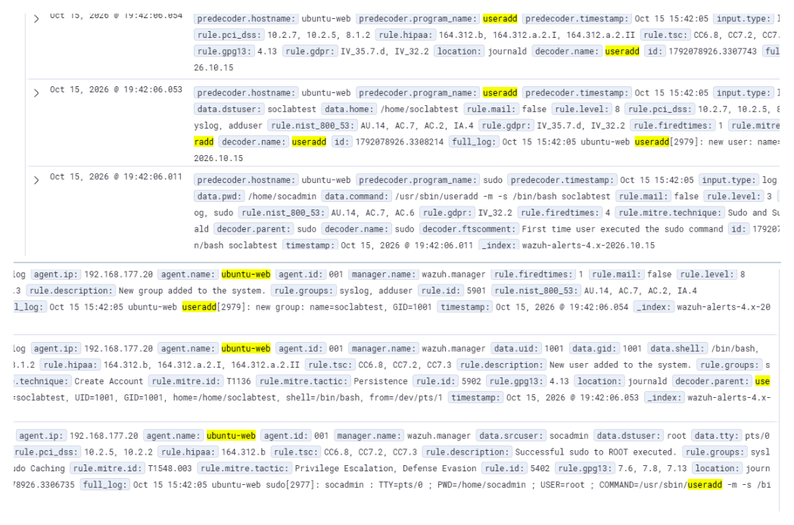
Figure 13. useradd detected by Wazuh; rule 5902 records the new user.

7.4 Windows process creation through Sysmon
PowerShell launched C:\Windows\System32\notepad.exe. Sysmon Event ID 1 recorded the executable and its PowerShell parent. The Wazuh event shown in Figure 14 demonstrates receipt and parsing of this process creation. The custom lab-only rule 100150 raised the process execution to alert level 5.
Figure 14. Sysmon Event ID 1 for notepad.exe, including its PowerShell parent and image path (repeated as V1 evidence).

7.5 Failed Windows login
One incorrect password was entered for the win-client local account at the lock screen. Windows Security Event ID 4625 recorded an interactive failed logon (Logon Type 2). Wazuh mapped it to rule 60122 with level 5 and the description “Logon Failure - Unknown user or bad password.”
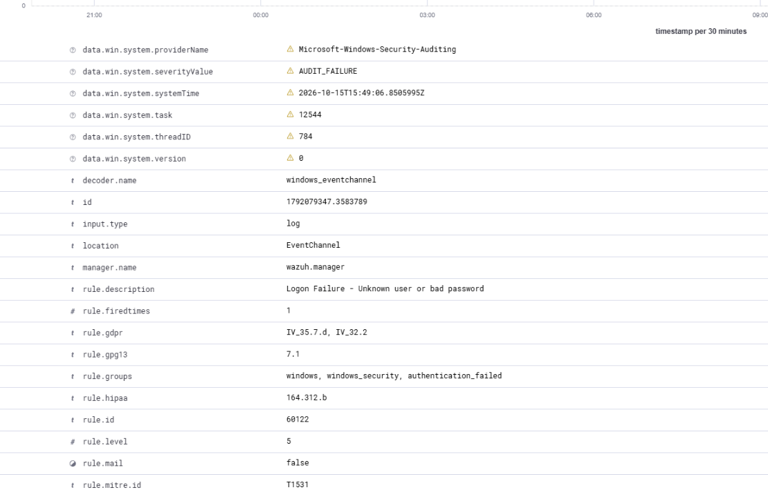
Figure 15. Event 4625 mapped to Wazuh rule 60122, severity level 5.

8. Event-to-alert flow (V2)
For a concrete example, consider the failed Windows login above. The pipeline is:
1. Windows Security: the incorrect password generates Event ID 4625 in the local Security event log.
2. Wazuh Agent: the agent on win-client reads the configured Event Log channel and forwards the record to 192.168.177.10.
3. Wazuh Manager: the event is decoded, checked against rules and reported as an authentication-failure alert (rule 60122).
4. Wazuh Indexer: the generated alert is indexed so it can be retrieved and searched. Filebeat is used by the Wazuh Docker deployment for forwarding alerts.
5. Wazuh Dashboard: an analyst searches Discover for the event, inspects its severity, time, endpoint and related fields.
This demonstrates the difference between source telemetry (the original Event ID 4625) and a SIEM alert (the Wazuh rule decision based on that telemetry). On the physical host, the Dashboard may display UTC event timestamps adjusted to the browser’s UTC+4 time zone.

9. Reliability, resource use and snapshots

9.1 Container and VM persistence (W4)
The Wazuh Compose stack was gracefully stopped and started on multiple occasions. A full siem-host reboot was also confirmed after alerts and agents were present. Both registered agents, previous alerts and the Dashboard remained available after bringing the services back online. These outcomes rely on persistent Docker volumes and files; no redeployment or re-enrollment was necessary.
Operational sequence: check docker compose ps; stop and start the existing stack with docker compose stop/start as needed; shut down with sudo shutdown -h now; after boot, allow the Manager and Indexer to initialize, check agents and retrieve a pre-existing alert. The containers use restart: always and can restart with Docker on boot.

9.2 Container resource measurement (W5)
Container | Observed memory | Observed CPU
Wazuh Dashboard | 191.1 MiB | 0.02%
Wazuh Manager | 913.4 MiB | 124.13%
Wazuh Indexer | 1.443 GiB | 1.82%

Figure 16. Container memory measurements captured with docker stats --no-stream.
Total displayed memory use was approximately 2.52 GiB. CPU on the Manager remained elevated at measurement time, so the memory figures are a point-in-time observation after restart, not a guarantee of a fully idle CPU state.

9.3 VMware recovery points (L5)
The three VMs have both required snapshots: w1-clean-install before the Wazuh build and w1-done after Week 1 completion. siem-host also has a w1-pre-password-change snapshot. This extra checkpoint was taken immediately before replacing administrator credentials and modifying Indexer security settings, so the working deployment could be restored if the password-change procedure made the Dashboard or services inaccessible.
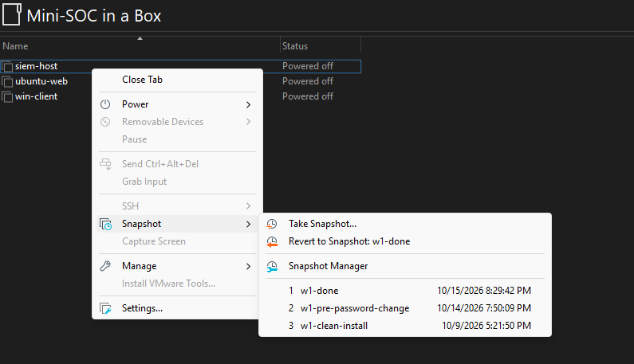
Figure 17. siem-host: clean-install, pre-password-change and final snapshots.
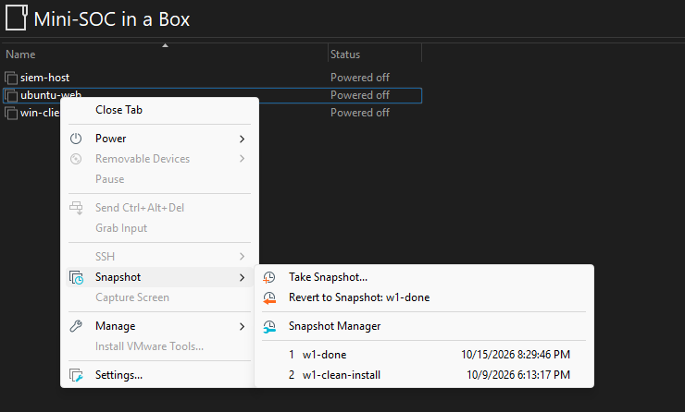
Figure 18. ubuntu-web: clean-install and final snapshots.
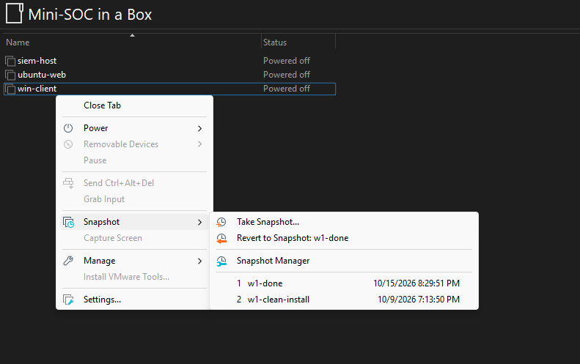
Figure 19. win-client: clean-install and final snapshots.

10. Troubleshooting and lessons learned
This section focuses only on issues that required technical diagnosis or a configuration change.

Ubuntu time service
Observed issue. Initial synchronized status was “no” after removing temporary NAT from ubuntu-web.
Investigation / resolution. Chrony was installed and configured as an NTP service on siem-host, including access for the host-only subnet. ubuntu-web was configured to use 192.168.177.10.
Verified outcome. timedatectl timesync-status and later screenshots showed synchronization to the lab reference.

Windows NTP resynchronization
Observed issue. w32tm /resync initially returned “no time data was available” even though the peer was configured.
Investigation / resolution. Peer status, Windows Time-Service events and the VMware Tools timesync setting were checked, then repeated validation after the service processed valid NTP samples.
Verified outcome. Windows reported source 192.168.177.10, Leap Indicator 0 and successful synchronization events (35/37).

Normal Sysmon process not visible as an alert
Observed issue. Sysmon Event ID 1 existed locally for notepad.exe, but ordinary Wazuh alert searches did not show it initially.
Investigation / resolution. The built-in Sysmon process rule 61603 was found at level 0. A scoped level-5 custom test rule 100150 matched notepad.exe.
Verified outcome. Wazuh Discover showed the process path, its PowerShell parent and the relevant Windows Event ID.

Selected work-log milestones
Phase | Short entry
Foundation | Created three VMs, host-only networking, static addressing and baseline snapshots.
Time & isolation | Validated NTP synchronization and removed temporary NAT from endpoints.
SIEM deployment | Installed Docker, generated certificates and started three Wazuh 4.14.8 containers.
Credential hardening | Took a safety snapshot, changed administrator credentials and applied Indexer security configuration.
Telemetry | Enrolled ubuntu-web and win-client; configured Sysmon collection.
Verification | Produced all five required detections; confirmed persistence, resource use and final snapshots.

11. Operating procedure

11.1 Starting the lab
Power on siem-host first and allow Docker services to initialize. Then start ubuntu-web and win-client. From the physical Windows 11 host, connect to 192.168.177.10 over SSH or open the Dashboard in a browser.
ssh socadmin@192.168.177.10
cd ~/wazuh-docker/single-node
sudo docker compose ps
sudo docker compose start # only if stopped
When all containers are Up and the Dashboard is ready, confirm that ubuntu-web and win-client are Active. If the containers have never been created on a fresh build, use docker compose up -d instead of start.

11.2 Shutdown and data preservation
cd ~/wazuh-docker/single-node
sudo docker compose stop # optional controlled stop
sudo shutdown -h now
Ubuntu can also shut down gracefully without an explicit Compose stop; Docker will attempt to stop containers during system shutdown. Avoid force-power-off and avoid docker compose down -v because removing Docker volumes can destroy the indexed data that the lab must preserve. Shut down the endpoint VMs normally.

11.3 Routine verification
sudo docker compose ps
sudo docker compose logs --tail=40 wazuh.manager
sudo docker stats --no-stream
From Windows, use Get-Service WazuhSvc. From Linux, use systemctl is-active wazuh-agent. The Dashboard should show two Active agents and historical alerts should remain searchable.

12. Conclusion
Week 1 delivered an operational three-VM Mini-SOC with isolated endpoint networking, synchronized clocks, Apache on Linux, Sysmon process monitoring on Windows and centralized detection using Wazuh 4.14.8. All five intentionally generated security events were observed in the Dashboard, and the environment was exercised across service restarts and VM reboot. Resource measurements and VMware recovery points support repeatable operation for subsequent project weeks.

